Project Design Phase-II
Data Flow Diagram & User Stories

Date | 10 July 2026
Team ID
Project Name
Maximum Marks | 4 Marks

Data Flow Diagrams:
A Data Flow Diagram (DFD) is a traditional visual representation of the information flows within a system. A neat and clear DFD can depict the right amount of the system requirement graphically. It shows how data enters and leaves the system, what changes the information, and where data is stored.
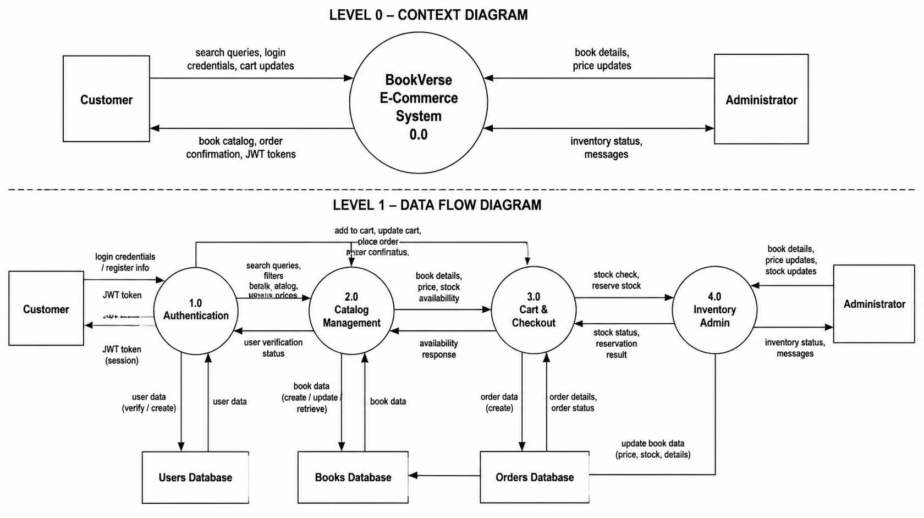

User Stories
Use the below template to list all the user stories for the product.
User Type | Functional Requirement (Epic) | User Story Number | User Story / Task | Acceptance criteria | Priority | Release
Customer (Web/Mobile) | Registration | USN-1 | As a user, I can register for the application by entering my email, password, and confirming my password. | I can successfully create an account and my password is encrypted in the database. | High | Sprint-1
Customer (Web/Mobile) | Login | USN-2 | As a user, I can log into the application by entering my email & password. | I receive a JWT token and am redirected to the homepage/shop. | High | Sprint-1
Customer (Web/Mobile) | Catalog | USN-3 | As a user, I can view a responsive grid of available books fetched from the database. | The UI displays book covers, titles, authors, and prices correctly on all devices. | High | Sprint-1
Customer (Web/Mobile) | Catalog | USN-4 | As a user, I can search for books by title or author, and filter them by genre. | The displayed book list updates instantly to match my search/filter criteria. | Medium | Sprint-1
Customer (Web/Mobile) | Cart Management | USN-5 | As a user, I can add books to my shopping cart and update the quantity of items. | The cart badge updates immediately, and the total price reflects the current quantity. | High | Sprint-2
Customer (Web/Mobile) | Checkout | USN-6 | As a user, I can proceed to a secure checkout to finalize my purchase. | My order is successfully placed, and I receive an order confirmation message. | High | Sprint-2
Customer (Web/Mobile) | Dashboard | USN-7 | As a user, I can view my order history and profile details. | I can see past orders mapped to my specific user ID. | Low | Sprint-4
Administrator | Authentication | USN-8 | As an admin, I can log in and access a secure /admin dashboard. | Standard users are blocked from this route; only admins are permitted. | High | Sprint-3
Administrator | Inventory | USN-9 | As an admin, I can add a new book with a title, author, price, and cover image URL. | The new book is saved to the MongoDB database and immediately appears in the customer catalog. | High | Sprint-3
Administrator | Inventory | USN-10 | As an admin, I can edit existing book prices or delete out-of-stock books. | The database updates successfully and the changes reflect across the application. | High | Sprint-3
User Type | Functional Requirement (Epic) | User Story Number | User Story / Task | Acceptance criteria | Priority | Release
Customer (Web/Mobile) | Registration | USN-1 | As a user, I can register for the application by entering my email, password, and confirming my password. | I can successfully create an account and my password is encrypted in the database. | High | Sprint-1

